COMMUNICATE No. 4
Kaunas
2024-06-01

26th On-site International High Frequency Radio Communication Competition

„Lithuanian HF CUP“ SPONSORS and ORGANIZERS

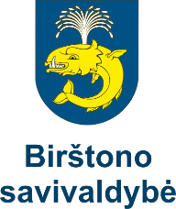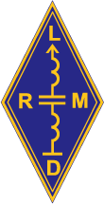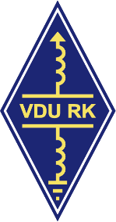
Prizes:

Lithuanian Radio Sports Federation – Main CUP for Winner;

Lithuanian Amateur Radio Society – 2nd Place;

Vytautas Magnus University Radio Club – 3rd Place;

Sponsors:

Birštonas municipality

Birštonas Sports Centre

Kaunas University of Technology

JSC „Vikompa“
Become a sponsor ! Call +370-691-44414 Rolandas LY5AA

Organizers:

LRSF, KTU RC

